YENS ACUPUNCTURE & TCM

QUESTIONNAIRE
DATE: PATIENT’S NAME:

TEL:

1.DO YOU LIKE WIND BLOW YOUR BODY？

2.DO YOU FEEL CHILLNESS？

3.DO YOU FEEL ALTERNATIVE HOT AND COLD？

4.DO YOU HAVE BITTER TEST IN YOUR MOUTH？

5.DO YOU FEEL IRRITATE EASILY？

6.DO YOU HAVE DIZZINESS？

7.DO YOU HAVE GOOD APPETITE？

8.DO YOU FEEL BLOATED EASILY？

9.DO YOU FEEL NAUSEA

10.DO YOU FEEL ABNORMAL THIRST？

11.DO YOU LIKE TO DRINK WARM OR COLD WATER？

12.DO YOU HAVE GOOD BOWEL MOMVENT EVERYDAY？

13.IF THE ANSER IS YES, HOW MANY TIMES A DAY？FIRM OR LOOSE？

14.IF THE ANSER IS NO, HOW OFTEN DO YOU HAVE ONE？FIRM OR LOOSE？

15.DO YOU HAVE ABNORMAL URINE？

16.WHAT IS THE COLOR OF URINE? (LIGHT YELLOW, DARK YELLOW OR PALE?)

17.HOW ABOUT URINE STRING?STRONG OR WEAK?

18.IS YOUR HAND WARM OR COLD？

19.IS YOUR FEET WARM OR COLD？

20. IS YOUR FORE HEAD WARM OR COOL？

21.DO YOU HAVE GOOD ENERGY OR FEEL TIRED EASILY？

22.DO YOU SLEEP GOOD?

23.WILL YOU WAKE UP DURING SLEEP?
24.DO YOU SLEEP LATE？(AFTER 11:00PM)

25.IF YOU ALWAYS WAKE UP IN THE MIDNIGHT, WHAT TIME IS IT?(11:00PM-1:00AM？1:00AM-3:00AM？3:00AM-5:00AM？)

26.PERIOD

CYCLE:______DAYS, DURATION:_______DAYS

DO YOU HAVE BLOOD CLUTS?

DO YOU HAVE CRAMP PAIN?

27.WHAT IS YOUR TONGUE COLOR?(PINK, RED, DARK RED)

28.WHAT IS YOUR TONGUE COATING?(THIN OR THICK? WHITE OR YELLOW? DRY OR WET?)

29.DO YOU HAVE ANY PHLEGM? IF YES, WHAT IS THE COLOR?

30.DO YOU FEEL ANY PAIN? MARK IT IN THE CHART.
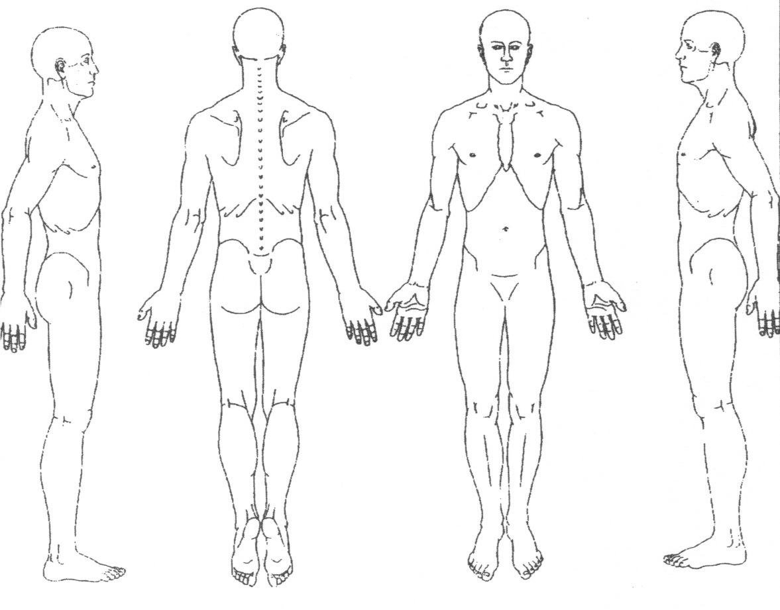

31.REASON FOR VISIT

32.OTHERS

